PROJECT DEVELOPMENT PHASE

Project Development-Delivery of sprint-1

REGISTRATION:
Register.html:
<html>
<head>
<title>Registration</title>
<link rel="stylesheet" type="text/css" href="{{url_for('static',filename='newstyle.css')}}">
<link rel="stylesheet" type="text/css" href="{{url_for('static',filename='font/css/all.min.css')}}">
<nav class="header">
<ul>
<li><a href="/about1" ><i class="fa-regular fa-address-card"></i> About us</a></li>
<li><a href="/register1" ><i class="fa fa-edit"></i> Register</a></li>
<li><a href="/login1" ><i class="fa-solid fa-right-to-bracket"></i> login</a></li>
<li><a href="/" ><i class="fa-solid fa-house"></i> Home</a></li>
</ul>
</nav>

</head>
<body class="bg2">
<br><br><br>
<div class="row">
<div class="column left"></div>
<div class="column right">
<center>
<fieldset class="form" style="width:500px; height:600px; ">
<legend style="font-size:30px;">Register</legend>
<form action="{{ url_for('register') }}" method="post">
<br><br>
<div class="msg">{{ msg }}</div>
<br><br>
<label>User Name</label>&nbsp;&nbsp;&nbsp;&nbsp;&nbsp;&nbsp;&nbsp;&nbsp;
&nbsp;&nbsp;&nbsp;&nbsp;&nbsp;&nbsp;&nbsp;
<input type="text" name="username" placeholder="Enter user name">
<br><br><br>
<label>Email</label>&nbsp;&nbsp;&nbsp;&nbsp;&nbsp;&nbsp;
&nbsp;&nbsp;&nbsp;&nbsp;&nbsp;&nbsp;&nbsp;&nbsp;&nbsp;&nbsp;&nbsp;
&nbsp;&nbsp;&nbsp;&nbsp;&nbsp;&nbsp;
<input type="email" name="email" placeholder="Enter email">
<br><br><br>
<label>Account Number</label>&nbsp;&nbsp;&nbsp;&nbsp;&nbsp;&nbsp;
<input type="text" name="accno" placeholder="Enter Account Number">
<br><br><br>
<label>Password</label>&nbsp;&nbsp;&nbsp;&nbsp;&nbsp;&nbsp;&nbsp;&nbsp;&nbsp;&nbsp;&nbsp;
&nbsp;&nbsp;&nbsp;&nbsp;&nbsp;&nbsp;
<input id="password" name="password" type="password" placeholder="Enter Your Password" />
</br></br></br>
<label>Confirm Password</label>&nbsp;&nbsp;&nbsp;&nbsp;
<input id="confirmpassword" name="confirmpassword" type="password" placeholder="confirm Password" />
</br></br></br>
<label>Phone Number</label>&nbsp;&nbsp;&nbsp;&nbsp;&nbsp;&nbsp;&nbsp;&nbsp;&nbsp;&nbsp;
<input type="text" name="no" placeholder="Enter Phone Number" >
<br><br><br>
<label>userid</label>&nbsp;&nbsp;&nbsp;&nbsp;&nbsp;&nbsp;&nbsp;&nbsp;&nbsp;&nbsp;
<input type="text" name="userid" placeholder="userid" >
<br><br><br>
<p><center><input class="button" type="Submit" value="REGISTER"/></center></p>
<p>Do you have an account? <a href="/login"> Sign In here</a></p>
</form>
</fieldset>
</center>
</div>
</div>
</body>
</html>

App1.py
@app.route('/register', methods =['GET', 'POST'])
def register():
global email
msg = ''
if request.method == 'POST':
username = request.form['username']
email = request.form['email']
accno = request.form['accno']
password = request.form['password']
confirmpassword = request.form['confirmpassword']
phone_no=request.form['no']
user_id=request.form['userid']
sql = "SELECT * FROM users WHERE username = ? "
stmt = ibm_db.prepare(Conn,sql)
ibm_db.bind_param(stmt,1,username)
ibm_db.execute(stmt)
account = ibm_db.fetch_assoc(stmt)
print(account)
if account:
msg = 'Account already exists !'
elif not re.match(r'[^@]+@[^@]+\.[^@]+', email):
msg = 'Invalid email address !'
elif not re.match(r'[A-Za-z0-9]+', username):
msg = 'Username must contain only characters and numbers !'
elif not username or not password or not email:
msg = 'Please fill out the form !'
elif password!=confirmpassword:
msg='password and confirm password not match!!'
else:
insert_sql = "INSERT INTO users VALUES (?, ?, ?,?,?,?)"
stmt = ibm_db.prepare(Conn,insert_sql)
ibm_db.bind_param(stmt, 1, username)
ibm_db.bind_param(stmt, 2, email)
ibm_db.bind_param(stmt, 3, accno)
ibm_db.bind_param(stmt, 4, password)
ibm_db.bind_param(stmt, 5, phone_no)
ibm_db.bind_param(stmt, 6, user_id)
ibm_db.execute(stmt)
msg = 'You have successfully registered !'
elif request.method == 'POST':
msg = 'Please fill out the form !'
return render_template('register.html', msg = msg)

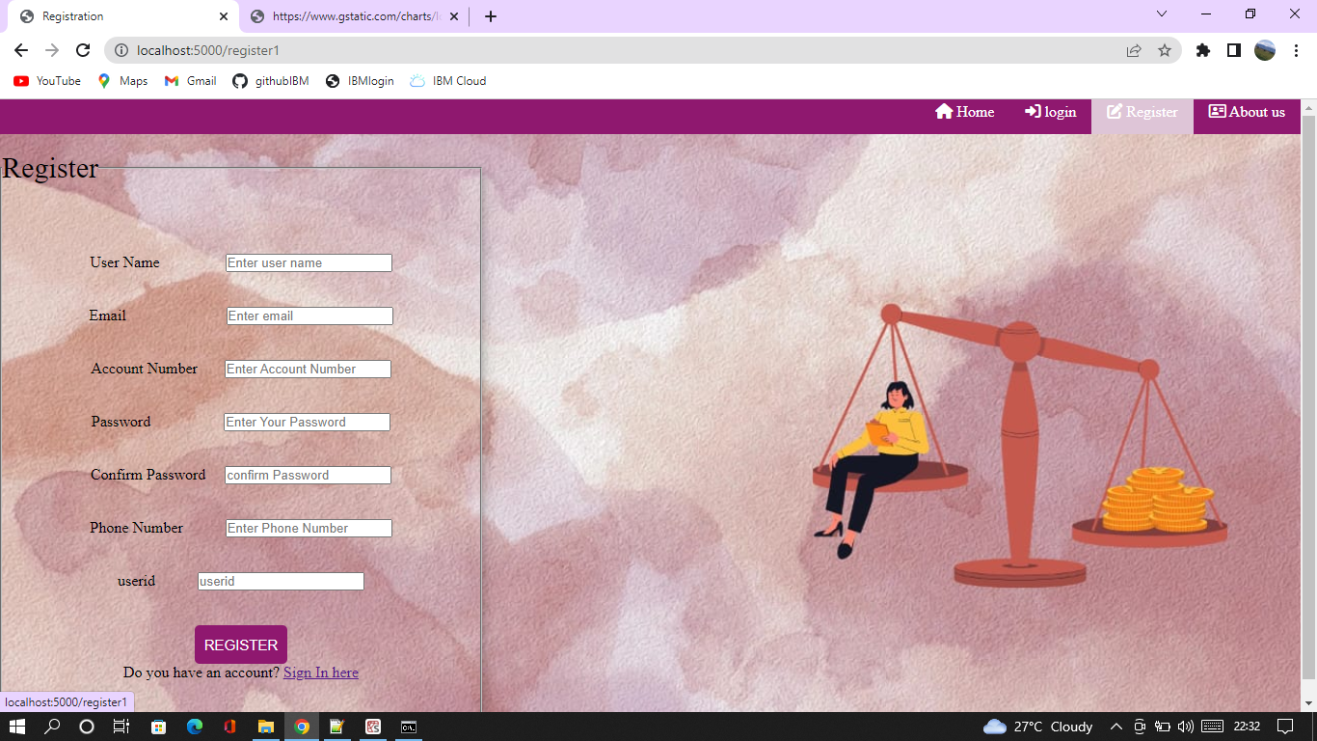

LOGIN:
Login.html
<html>
<head>
<meta charset="UTF-8">
<title> Login </title>
<link rel="stylesheet" type="text/css" href="{{url_for('static',filename='newstyle.css')}}">
<link rel="stylesheet" type="text/css" href="{{url_for('static',filename='font/css/all.min.css')}}">
<nav class="header">
<ul>
<li><a href="/about1"><i class="fa-regular fa-address-card"></i> About us</a></li>
<li><a href="/register1"><i class="fa fa-edit"></i> Register</a></li>
<li><a href="/login1"><i class="fa-solid fa-right-to-bracket"></i> login</a></li>
<li><a href="/"><i class="fa-solid fa-house"></i> Home</a></li>
</ul>
</nav>
</head>
<body class="bg2">
<div class="row">
<div class="column left"></div>
<div class="column right">
</br></br></br></br></br>
<center>
<fieldset class="form" style="width:500px; height:300px; ">
<legend style="font-size:30px;">Login</legend>
<form action="{{ url_for('login') }}" method="post" align="center">
</br></br>
<div class="msg">{{ msg }}</div>
</br></br>
<label>User Name</label>&nbsp;&nbsp;&nbsp;&nbsp;&nbsp;
<input id="username" name="username" type="text" placeholder="Enter Your Username" /></br></br>
<label>Password</label>&nbsp;&nbsp;&nbsp;&nbsp;&nbsp;&nbsp;&nbsp;
<input id="password" name="password" type="password" placeholder="Enter Your Password" /></br></br></br>
<input class="button" type="submit" value="Sign In"></br></br>
<p>Don't have an account? <a href="/register"> Sign Up here</a></p>
</form>
</fieldset>
</center>
</div>
</div>
</body>
</html>

App1.py

@app.route('/login', methods =['GET', 'POST'])
def login():

msg = ''
if request.method == 'POST'and 'username' in request.form and 'password' in request.form:
username = request.form['username']
password = request.form['password']
stmt = ibm_db.prepare(Conn,'SELECT * FROM users WHERE username = ? AND password = ?')
ibm_db.bind_param(stmt,1,username)
ibm_db.bind_param(stmt,2,password)
ibm_db.execute(stmt)
account = ibm_db.fetch_assoc(stmt)
if account:
session['loggedin'] = True
session['username'] = account['USERNAME']
msg = 'Logged in successfully !'
return render_template('hi.html', msg = msg)
else:
msg = 'Incorrect username / password !'
return render_template('login.html', msg = msg)

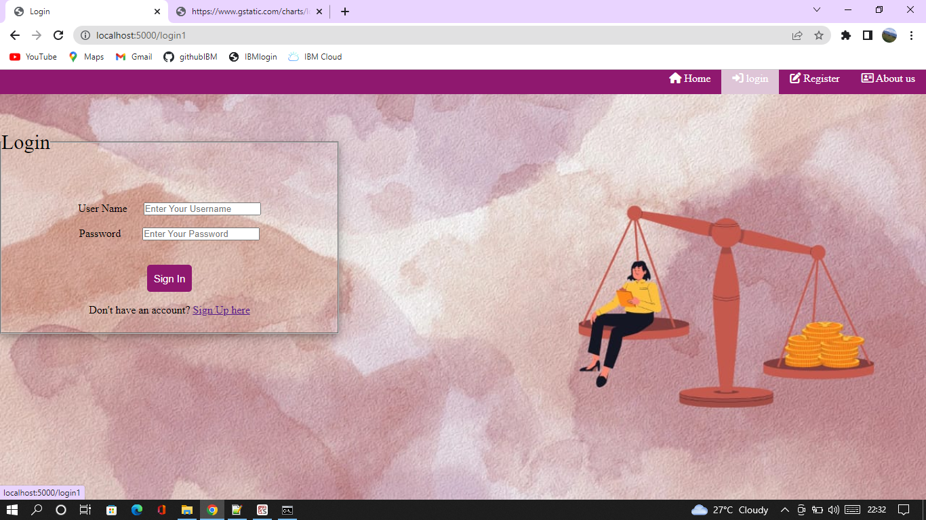

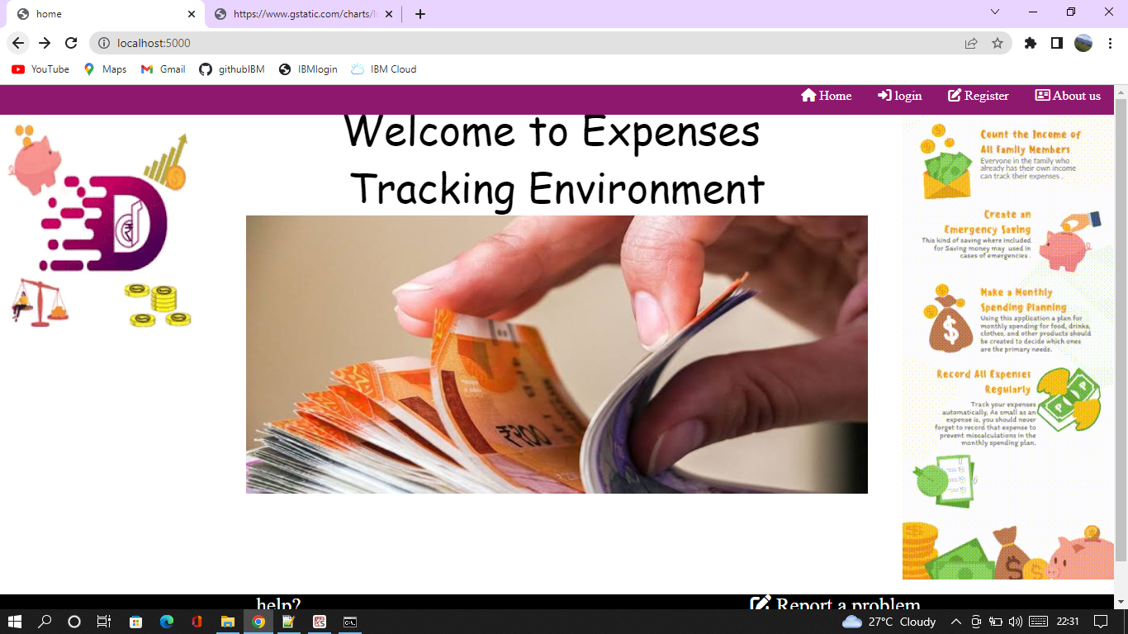

LOGOUT:
App1.py
@app.route('/logout')
def logout():
session.pop('loggedin', None)
session.pop('id', None)
session.pop('username', None)
return redirect(url_for('login'))

